Part I: Deep Origins

**Biological Vision**

The Evolution of Vision:

Vision has been a crucial factor in the evolution of life on earth. About five hundred fifty million years ago, in the prehistoric Cambrian period, the number of species on the planet began to surge! Our understanding today of the causal factors behind this surge in biodiversity are still evolving but current research (Andrew Parker’s “Light Switch Theory” in particular) indicates that a critical factor was the development of light detectors in animals like the trilobite (a small marine animal related to modern crabs). This development of light detectors was in turn triggered by visibility changes in the earth’s atmosphere.

Now, commonsense tells us that, given the presence of light, a visual system (even a simple one) would enable a powerful set of survival capabilities. With vision, animals could spot food, friends, foes, and obstacles at much longer distances. This was an enormous advantage. Other senses such as smell, also enable animals to detect these as well. But the accuracy, distance and “light-speed” immediacy of vision, are unmatched! So, the fact that the trilobite could see, set off an evolutionary “arms race”; one that, according to some scientists, triggered the Cambrian explosion as the trilobite’s prey, as well as its predators, had to evolve rapidly just to survive!

* Here is a graph of time against genera (categories of related species). Notice in the graph that, the number of species on our planet began to increase rapidly 550 million years ago i.e. during the prehistoric Cambrian period. The horizontal axis represents the period in millions of years and ranges from 550 million years before the current era to the present time. The vertical axis represents the genera from 0 to 5, in terms of thousands of genera. This single curve-graph succinctly shows the rise of species from the pre-historic Cambrian era until today. There is a small increase from the Cambrian era that remains constant for a while, when it attains one thousand genera. At this point, after a subtle dip, a gradual increase is noticed, reaching around 4000 genera in the present generation.*

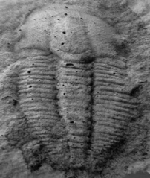 

*Trilobyte Fossils. The fossil on the left is from Himachal Pradesh!)*

But the recognition of the impact of light and vision on evolution and biodiversity was an idea that took its time to arrive.

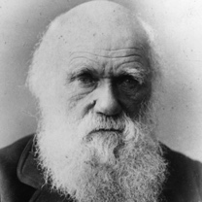 Charles Darwin, best known for his contributions to the science of

Evolution and one of the most influential figures in human history, had a hard time comprehending how life diversity could, so suddenly, burst into evolution during the Cambrian period. After all, natural selection emphasized *small gradual changes over a long period of time, not rapid bursts*. Hence, in his lifetime, he could not adequately explain the Cambrian explosion from a classic evolutionary theory perspective. But fossil records clearly show that complex multi-cellular organisms existed in the Precambrian periods. Trilobites and other famous Cambrian fossils were preceded by a number of creatures that "swarmed" in the prehistoric seas. So, his basic evolutionary hypothesis was proven via scientific evidence in posterity, which is a tribute to the veracity of his hypothesis but what was not completely clear was why there was such an explosion.

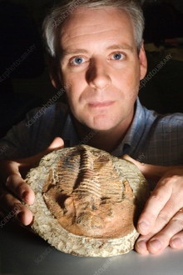 Andrew Parker, a Zoologist from Oxford, in his Light Switch Theory states that *vision* was the key to unlocking the Cambrian explosion puzzle. He does a good job of bridging the gap in our understanding of the Cambrian period in his book “In the Blink of an Eye: How Vision Sparked the Big Bang of Evolution”. Here’s how he addresses Darwin’s issues with the implausible pace of biodiversity during the Cambrian period:

*“Revolutions in evolutionary theory have occurred since Darwin’s time. We know now that the history of life on Earth has been dominated by long periods of gradual evolution— ‘micro-evolution’ —or even a complete standstill. But these periods ended abruptly and were replaced by ‘macro-evolution’—short but prolific bursts in evolutionary activity, hence supporting a so-called ‘punctuated equilibrium’ model for evolutionary history. Darwin and others of his time cannot be blamed for overlooking macro-evolution because its discovery was a consequence of twentieth-century fossil finds and the development of modern biochemical techniques.”*

In fact, his perspectives on the Cambrian period itself is a bit different from other scientists:

*” [….] the Cambrian period is not properly described simply by its great life diversity. This flippant approach to the most dramatic event in the history of life is misleading in the extreme, and, has led to a number of false explanations for the cause of the event. […] The Cambrian explosion is the evolutionary episode in which under remorseless selection pressure* ***all*** *animal phyla attained complex external forms. In other words,* ***it is the event during which animal phyla changed from all looking the same to looking different****. […] By external parts of animals, I refer to the materials, the colors and the shapes of the outer layers. These have a closer association with the environment than do with internal organizations. […] Think of the protective spines, swimming paddles, burrowing shapes, grasping arms, eyes and colors.”*

Parker’s Light Switch Theory postulates that once the atmospheric changes that occurred around the Cambrian increased the amount of light reaching the Earth, the species survival benefits of vision became clear. Therefore, eyes emerged rapidly, and nervous systems developed as part of the co-evolution of the eye and the brain. Vision accelerated predation as, with vision, predators were able to see, pursue, and capture prey better.  Hard parts assisting predation such as teeth and jaws emerged to support predation. In evolutionary prey response, *protective* hard parts such as shells evolved to protect smaller animals from the predators. Newer predatory behavior and countermeasures evolve. For example, with the arrival of vision for predators, prey developed camouflage. And the process continued. All animals *had* to adapt to the presence of eyes not only in terms of their [the animals’] color, but also their shape and behavior i.e. all factors affecting an animal’s appearance on a retina. Species that didn't adapt died out (predator and prey alike).

Andrew Parker’s Light Switch Theory is controversial among biologists, but it is cited with approval by many scientists not only because it possibly explains the reason for the Cambrian explosion, but also *sets apart the* *eyes and vision as one of the driving forces of natural selection and evolution*. That is a radical but plausible viewpoint. Parker’s theory also suggests an evolutionary reason for the *overwhelming supremacy of the human vision over the other senses*, and in general of the gradual *natural predominance of vision over olfaction in primates*. The importance of vision in humanity’s evolutionary journey and the fact that so much of our brain is involved in visual processing, is also the reason why AI has and continues to be obsessed with Machine Vision!

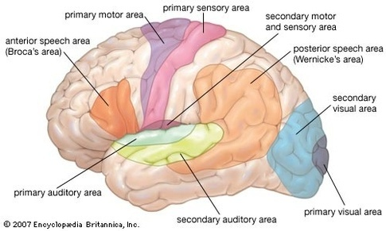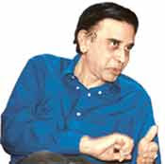 *Talking about the dominance of vision over olfaction,* *roughly, 2/3 (60%+) of the brain is "involved" in vision, the breakdown being 20% dedicated to "visual-only" function, the other 40% doing vision+touch, or vision+motor, or vision+attention, or vision+spatial navigation, or vision+meaning, etc. There’s a smooth gradation from areas fully specialized to one thing to areas involved in many things. Smell, physically is underneath and not visible!*

Today, we know for a fact that in modern mammals, a large proportion of the cerebral cortex (the outer gray matter of the brain) is involved in visual perception. In the half-billion years since trilobites developed rudimentary vision, the complexity of the sense has increased considerably. So has our understanding of it. But just as with other important ideas, our understanding of the process of perception by our brain has been a long and slow dawning through time.

**Evolution of our perspectives on vision through Ancient and Medieval periods**

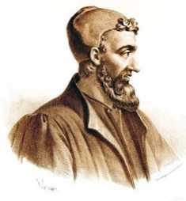 Galen (c.130-200) was a physician, anatomist, writer and philosopher who became the most famous physician in the Roman Empire *(he was the personal physician of the emperor Marcus Aurelius).* His theories dominated European medicine for *1,500 years*. Galen, who studied in Alexandria (where bodily dissection was allowed), introduced the concept of *visual disparity* i.e. the two eyes see the same object differently, in the 10th chapter of his work entitled *On the Use of the Parts of the Human Body*. The story goes that he had intended to omit that chapter as it would contain too many difficult mathematical formulae, but then had a dream which persuaded him to keep it in. From Galen we all derive our use of many anatomical terms for the parts of the eye such as the retina or the crystalline lens.

Avicenna (Ibn Sina) (980-1037), a visionary Persian polymath was the first to overturn the, then common, idea that *the* *eye* emitted rays that bounced off an object being viewed, thus triggering perception. Avicenna determined that actually, light rays go into the eye and that the lens of the eye played in a role in the visual process. William Osler, one of the founding fathers of modern medicine and a founder of Johns Hopkins University described Avicenna's book as the most important work ever...it was used in medical schools beyond the late 14th century!

*'it is not the ray that leaves the eye and meets the object that gives rise to vision, but rather the form of perceived object passes* *into the eye and is transmuted by the transparent body, that is, the lens'.*

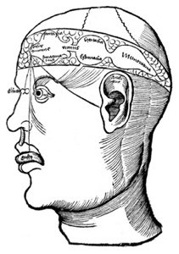In 1503 Gregor Reisch, a well-known humanist, published *Margarita philosophica*, a brief encyclopedia of knowledge, intended as a textbook for young students. In it we find mention of Reisch's cell theory which (though anatomically inaccurate) recognized that a mechanistic process was at work inside our brain. Reisch suggested that images passed through a *hierarchical chain of cells inside the brain*. You can see this chain in the diagram to the left. The eyes input information to the first set of cells, the “sensus commensis”. This information was then relayed to the second and third set of cells for *progressively higher thought processing*. For its time, this was extremely sophisticated thinking about the process of vision and cognition.

**Da Vinci and the Early Modern Period**

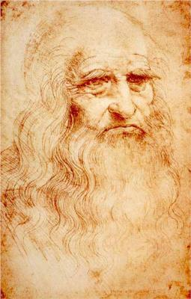Leonardo da Vinci, the great Italian polymath had a spirit of scientific inquiry and a mechanical inventiveness that were centuries ahead of their time. The unique fame that Leonardo had rests largely on his ability to pursue his unlimited desire for knowledge despite setbacks. It guided all his thinking and behavior. An artist by [disposition](https://www.merriam-webster.com/dictionary/disposition) and endowment, he considered his *eyes* to be his main avenue to knowledge; to Leonardo, sight was man’s highest sense because it alone conveyed the facts of experience immediately, correctly, and with certainty. Hence, every phenomenon perceived became an object of knowledge, and *saper vedere* (“knowing how to see”) became the great theme of his studies.

Leonardo studied vision extensively and was the first to propose the theory that *the inverted retinal image was actually re-inverted inside the brain*. Below, you can see two of Leonardo's drawings, dating from 1490 and 1506 respectively. The third image demonstrates his theory of the *re-inversion of an inverted retinal image*.

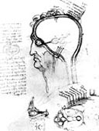

1490 Drawing by Da Vinci

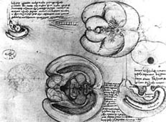

1506 Drawing by DaVinci

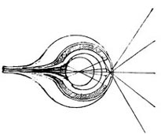

DaVinci’s Inverted retinal image

**The Seventeenth Century**

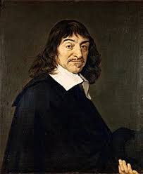Rene Descartes is considered the first modern philosopher and is famous for having made an important connection between geometry and algebra, which allowed for the solving of geometrical problems by way of algebraic equations. He is also famous for having promoted a new conception of matter, which allowed for the accounting of (bio)physical phenomena by way of mechanical explanations and most famously for having written a relatively short work, *Meditationes de Prima Philosophia* (*Meditations On First Philosophy*), published in 1641, in which he provides a philosophical groundwork for the possibility of the sciences.

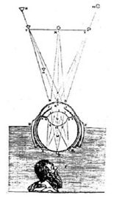 As part of a series of experiments on the mechanics of biological vision, Descartes stripped the sclera and choroid off the eye of an ox and performed a projection experiment onto a piece of paper and proved that the retina initially actually sees an *inverted image* and hence concluded it indeed was the brain that did the second inversion. The diagram on the left, from Descartes' *La Dioptrique* (1637), shows the Descartes observing the retinal image.

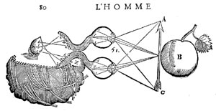Later, in his *Traité de l'Homme* (finished by 1648 but not published until 1664, after his death) Descartes thought of the brain as a machine with fibers running from the eyes like optical cables. These formed a rudimentary visual pathway. The inner soul within the brain then viewed the image transferred to it along the pathway by vibrational forces. You can see the two separate vibrating paths in his drawing on the left which shows the eyes looking at an apple and the image travelling to an artist's representation of the soul.

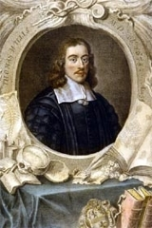 That same year of 1664 an anatomist, often referred to as the 'Father of Neurology', Thomas Willis (1621-1675), investigated the brains of different animals. The illustrations of his findings, published as the *Cerebri Anatome*, were drawn by Sir Christopher Wren the architect.

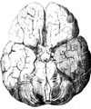Willis rejected the idea that the actual substance of the brain (or some fluid within it) performed its functions. He concluded that the performance of the human visual function was closely related to an *extensive cerebral cortex* and that was why man had better memory than many animals. Infact, the ophthalmic branch of the fifth nerve is called Willis' Nerve.

In 1682 William Briggs (1650-1704) developed the work of Willis when he described optic pathways more thoroughly and hinted at the idea that the retinal nerve fibres from the two eyes may cross over at some point behind the eye. (Newton's *Opticks*, already written but not yet published, would confirm this in 1705). Briggs recognized that fusion occurred in the optic tract, not in the “soul”.

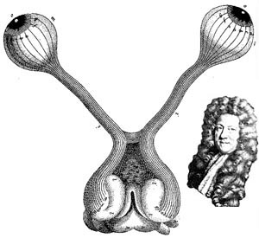Diagram of the visual pathway according to William Briggs (1682) bearing the first hint of an understanding of the decussation of fibers at the chiasma  
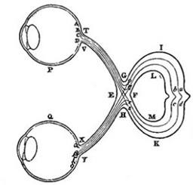Diagram of the visual pathway according to Isaac Newton, produced in 1682 but not publicized at the time

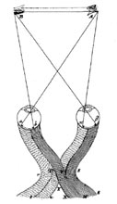

**The Eighteenth and Nineteenth Centuries**

In 1738 John Taylor produced an improved and very influential pathway diagram. The crossover of the fibers was now accepted. But the nineteenth century fascination with phrenology proved a false dawn for vision scientists. Amidst the largely discredited pseudo-science of men such as Franz Gall (1757-1828) there was a recognition that specific functions related to localized parts of the brain's cortex (neural localization). Unfortunately, this important point was thrown out with the bath water...a *setback for our subject that lasted well into the next century*. Here is a comparison between a standard phrenological head and the head of Gall himself. Beside that we have superimposed a nineteenth century image of the brain showing the visual region marked towards the back of the head.

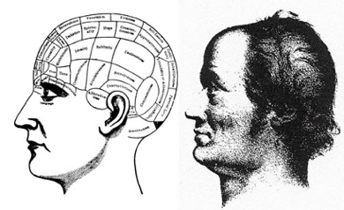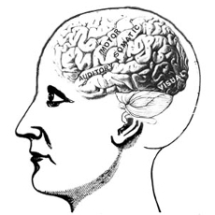

**The Twentieth Century**

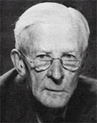 Lord Edgar Adrian (1889-1977) recorded sensory nerve impulses from the end of the 1920s and so gave us the notion of a pulse code with a frequency of transmission to the brain that can be measured.

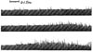 Here are his recordings from the sensory nerves of a cat's toe (1929).

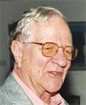

Horace Barlow: In the second half of the 20th century Horace Barlow FRS (b.1921) proved a key figure in interpreting how the eye detects distance in objects. This was research into stereoscopic vision, a phenomenon first described by Sir Charles Wheatstone (1802-75). In the 1950s Barlow also studied light and dark 'adaptation'. He described how certain animals learn from experience how to react to 'trigger factors' such a movement, light and outlines.

**Enter Hubel and Wiesel** 

Then, in the late 1950s, physiologists David Hubel and Torsten Wiesel (Figure 1.3) began carrying out research on how visual information is processed in the mammalian cerebral cortex (reference 3). Eventually this resulted in major progress in our understanding of the brain, significant advances in the treatment of childhood cataracts, and informing current research to enable computers to process images more like the human mind. In 1981, they were awarded a Nobel Prize in Physiology or Medicine for their groundbreaking work. (reference 4)

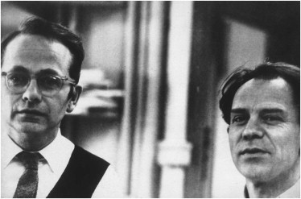

*Nobel Prize-winning neurophysiologists David Hubel (left) and Torsten Wiesel*

Hubel and Wiesel conducted their research by showing images to anesthetized cats while simultaneously recording the activity of individual neurons from the primary visual cortex, the first part of the cerebral cortex to receive visual input from the eyes.

 *Depicted in this figure is a primary visual cortex neuron being serendipitously activated by the straight edge of a slide (shown here as a lightbulb turned on to represent neuron activation). Hubel and Wiesel used a light projector to present slides to cats under anesthesia while they recorded the activity of neurons in the cats’ primary visual cortex. In the experiments, electrical recording equipment was implanted (yes, I know! Things are quite different now thanks to technology!) within the cat’s skull. (reference 2).*

In fact, the story of Torsten & Hubel’s journey to discovery of neuronal activation is so unique that Wiesel and Hubel were actually selected as the second winners of the *Golden Goose Award* in 2015 which honors researchers whose (federally funded) work *may have seemed odd or obscure when it was first conducted but has resulted in significant benefits to society!* The story goes that their extraordinary, research really took off with a simple, fortuitous accident with the kittens in their lab: *somebody pushed a glass slide too far on an overhead projector!*

The two researchers began their research with what was known i.e. light stimulates light-sensing receptor cells in the retina of the eye, and different receptor cells respond to stimuli in different parts of the retina's visual field.

But Hubel and Wiesel were studying *nerve cells, or neurons*, in higher-functioning areas of the brain which had not previously studied. They found these cells frustratingly unresponsive to even simple stimuli—small spots of light or a black dot on a clear glass slide projected onto a screen. Then, as the cats watched, one of the researchers *accidentally moved the glass slide a little too far*, bringing its faint *edge* into view. S*uddenly those same neurons began firing like mad* causing celebrations!



As they were adjusting their equipment, a single line moved across the screen at *a* *particular angle*—and that caused one cat's neuron to fire. The scientists then proceeded to study that single neuron for *nine* consecutive hours. Over the course of the next several months, Hubel and Wiesel made the first crucial steps forward in our understanding of visual processing. They found that particular neurons in the visual cortexes of cats and monkeys—the areas in their brains responsible for processing visual information—did *not* respond to simple points of light, but rather to *lines*, and in particular, lines and contours with specific orientations. Some neurons responded to horizontal lines, others to vertical, and still others to orientations in between. In addition, they found neurons responding to signals from both eyes, but usually one or the other would dominate.

*A simple cell in the primary visual cortex of a cat fires at different rates, depending on the orientation of a line shown to the cat. The orientation of the line is provided in the left-hand column, while the right-hand column shows the firing (electrical activity) in the cell over time (one second). A vertical line (in the fifth row from the top) causes the most electrical activity for this particular simple cell. Lines slightly off vertical (in the intermediate rows) cause less activity for the cell, while lines approaching horizontal (in the topmost and bottommost rows) cause little to no activity.*



*This figure shows how, via many hierarchically organized layers of neurons feeding information into increasingly higher-order neurons, gradually more complex visual stimuli can be represented by the brain! Here, you can see:*

1. *The eyes are focused on an image of a mouse’s head*
2. *Photons of light stimulate neurons located in the retina of each eye, and this raw visual information is transmitted from the eyes to the primary visual cortex of the brain*
3. *The first layer of primary visual cortex neurons to receive this input— Hubel and Wiesel’s* ***simple cells****— are specialized to detect edges (straight lines) at specific orientations. There would be many thousands of such neurons; for simplicity, we’re only showing just four in the figure*
4. *These simple neurons relay information about the presence or absence of lines at particular orientations to a subsequent layer of complex cells*
5. *The complex cells assimilate and recombine the information, enabling the representation of more complex visual stimuli such as the curvature of the mouse’s head*
6. *As information is passed through several subsequent layers, representations of visual stimuli incrementally become more complex and more abstract.*
7. *As depicted by the far-right layer of neurons, following many layers of such hierarchical processing (we use the arrow with dashed lines to imply that many more layers of processing are not being shown), the brain is ultimately able to represent visual concepts as abstract as a mouse, a cat, a bird, or a dog.*
8. *Hubel, D. H., & Wiesel, T. N. (1959). Receptive fields of single neurons in the cat’s striate cortex. The Journal of Physiology, 148, 574– 91. 4. The 1981 Nobel Prize in Physiology or Medicine, shared with American neurobiologist Roger Sperry.*

Over subsequent years, Hubel and Wiesel refined their understanding, mapping the visual centers of their feline and primate subjects with increasing precision. They found the visual cortex consisted of narrow columns of cells organized by eye preference and response to orientation, which they termed "ocular dominance columns" and "orientation columns." Combined these columns of cells formed an elegantly organized *functional map of neurons* that could process the complex input arriving from both of the animal's eyes.

Their inspiring work on cats’ visual cortex ultimately led to their winning the *1981 Nobel Prize in physiology or medicine*, which they shared with CalTech's Roger Sperry. The Nobel committee singled out their research for solving "one of the most well-guarded secrets of the brain: the way by which its cells decode the message which the brain receives from the eye."

Interestingly, soon after moving from Johns Hopkins to Harvard, with their newfound understanding of the brain's organizational structure in hand, Hubel and Wiesel sought to address a perennial question in biology namely, *nature or nurture*? To answer that question, they decided to tackle this problem from a vision perspective. Hubel and Wiesel began by studying the brains of newborn animals with *no visual experience*. Interestingly, they found that their feline and primate subjects were born with that *elegant functional map already in place in their visual cortices*. They found neurons that would respond onlyto oriented stimuli and that responded to stimulation of both eyes. They concluded that *nature* provides the neural connections necessary for these two basic response properties.

So, what then is the role of *nurture* for the normal development of the brain? Was vision fixed at birth? It was well known, from medical clinics, that children born with cataracts suffer from severe visual deficits *even after their opaque lens is removed a few years after birth*. If vision was prewired at birth, with the physical blockage gone, why would this be the case? After all, Hubel and Wiesel had shown that the necessary *neural connections* should be present at birth.

The researchers decided to address this question by studying the impact of raising kittens and monkeys from birth with *one eye covered and the other left open*. They found that the animal *behaved as if it was blind in the previously covered eye*, just like in a child after cataract surgery. The cause of this loss of vision turned out to be that *neurons in the visual cortex no longer responded to stimulation of the deprived eye but only vigorously to the normal eye*. The elegant patterns of ocular dominance the researchers had seen in healthy animals disappeared, with the one dominant eye taking over almost the entire visual cortex.

Over a series of experiments, they demonstrated that the brain could literally wire or rewire itself in response to external input (or lack thereof)—a phenomenon known as neuroplasticity—and that this ability seemed to fade with age. *Almost immediately*, this realization of the importance of early stimulation to the wiring of the visual cortex translated from the lab to the clinic, where doctors were working to treat children born with cataracts and other eye impairments. With Hubel and Wiesel's new understanding, doctors began treating children *as early as possible*, with *much better* outcomes. Truly, Hubel and Wiesel were pioneers of the visual system, exploring the physiology behind visual perception in animals, thereby teaching us much about how our own minds work.

This is critical for today's computing technology. For some tasks, like computing and factoring large numbers, silicon has our "wetware" beat handily, but for the complex tasks like visual processing, machines are only beginning to catch up to the human brain. This is no small matter. Teaching computers how our minds work is big business. The "machine vision" market is projected to be tens of billions of dollars. Hubel and Wiesel's work is extremely relevant to this burgeoning field. From a slip of the hand while cats watched images on a screen, have come better treatments for childhood vision disorders and teaching computers how to process images—a powerful example of how science can advance society in the most unexpected ways.

 *Here are some interesting points about our cerebral cortex:*

* *First, it is one of the more recent evolutionary developments of the brain, contributing to the complexity of mammal behavior relative to the behavior of older classes of animals like reptiles and amphibians.*
* *Second, while the brain is informally referred to as “gray matter” because the cerebral cortex is the brain’s external surface and this cortical tissue is gray in color, the bulk of the brain is in fact “white matter”.*
* *By and large, the white matter is responsible for carrying information over longer distances than the gray matter, so its neurons have a white-colored, fatty coating that hurries the pace of signal conduction. A coarse analogy could be to consider neurons in the white matter to act as “highways.”*
* *These high-speed motorways have a limited number of on-ramps or exits but can transport a signal from one part of the brain to another extremely fast. In contrast, the “local roads” of gray matter facilitate myriad opportunities for interconnection between neurons at the expense of speed.*
* *A gross generalization, therefore, is to consider the cerebral cortex— the gray matter— as the part of the brain where the most complex computations happen, affording the animals with the largest proportion of it— such as mammals, particularly the great apes like Homo sapiens— their complex behaviors.*

Today, through countless subsequent recordings from the cortical neurons of brain-surgery patients as well as noninvasive techniques like magnetic resonance imaging (MRI) neuroscientists have pieced together a fairly high-resolution map of regions that are specialized to process particular visual stimuli, such as color, motion, and faces.

*5. Especially functional MRI, which provides insight into which regions of the cerebral cortex are notably active or inactive when the brain is engaged in a particular activity.*

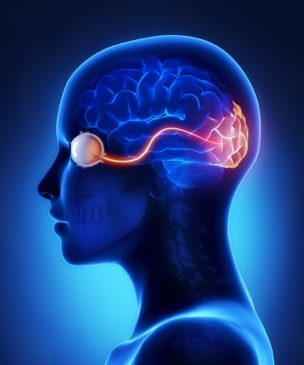 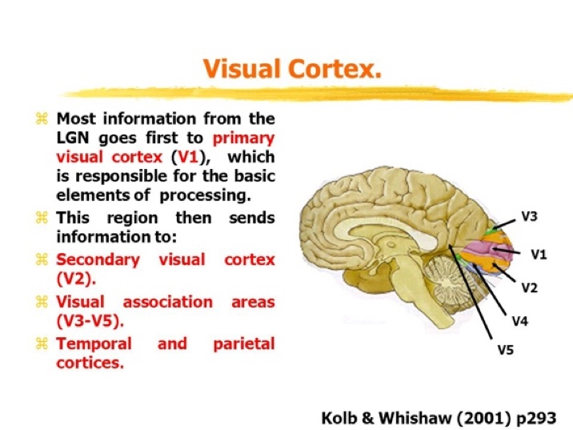

*The figure on the left above, shows how visual input travels from the eye to our visual cortex. The figure on the right above, shows the various regions of our visual cortex. The V1 region receives the input from the eyes and contains the simple cells that detect edge orientations. Through the recombination of information via myriad subsequent layers of neurons (including within the V2, V3, and V3a regions), increasingly abstract visual stimuli are represented. In the human brain (shown here), there are regions containing neurons with concentrations of specializations in, for example, the detection of color (V4), motion (V5), and people’s faces (fusiform face area).*

Machine Vision

So, you might have guessed by now, that we haven’t been discussing the biological visual system solely because it’s interesting (though the area is certainly fascinating!). We covered the biological visual system primarily because it serves as the *inspiration for the modern deep learning approaches to machine vision.*

*This figure provides a historical timeline of vision in biological organisms as well as machines. The top timeline, in blue, highlights the development of vision in trilobites as well as Hubel and Wiesel’s 1959 publication on the hierarchical nature of the primary visual cortex, as covered in the preceding section. The machine vision timeline is split into two parallel streams to call attention to two alternative approaches. The middle timeline, in pink, represents the deep learning (DL) path that is the focus of this book. The bottom timeline, in purple, meanwhile represents the traditional machine learning (ML) path to vision, which— through contrast— will clarify why deep learning is distinctively powerful and revolutionary.*

Enter the Neocognitron

Inspired by Hubel and Wiesel’s discovery of the simple and complex cells that form the primary visual cortex hierarchy, in the late 1970s the Japanese electrical engineer Kunihiko Fukushima proposed an *analogous architecture for* *machine vision*, which he named the neocognitron. In fact, Fukushima referred to Hubel and Wiesel’s work explicitly in his writing. His paper refers to three of their landmark articles on the organization of the primary visual cortex, including borrowing their “simple” and “complex” cell language to describe the first and second layers, respectively, of his neocognitron.

 Kunihiko Fukushima

*6. Fukushima, K. (1980). Neocognitron: A self-organizing neural network model for a mechanism of pattern recognition unaffected by shift in position. Biological Cynbernetics, 36, 193– 202.*

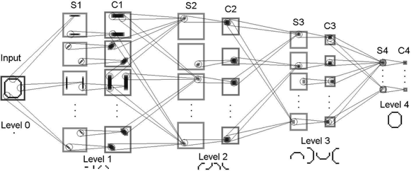

*By arranging artificial neurons in this hierarchical manner, these artificial neurons— like their biological inspiration earlier — generally represent line orientations in the cells of the layers closest to the raw visual image, while successively deeper layers represent successively complex, successively abstract objects.*

LeNet-5

While the neocognitron was capable of, for example, identifying handwritten characters, the accuracy and efficiency of Yann LeCun and Yoshua Bengio’s “LeNet-5” model made it a significant development. LeNet-5’ s hierarchical architecture (Figure 1.11) built on Fukushima’s lead and the biological inspiration uncovered by Hubel and Wiesel. A key point to note here is that LeCun and his colleagues benefited from superior data for training their model, faster processing power, and, most critically, the back-propagation algorithm.

 

Paris-born Yann LeCun is one of the preeminent figures in artificial neural network and deep learning research. LeCun is the founding director of the New York University Center for Data Science as well as the director of AI research at the social network Facebook.

 Yoshua Bengio is another of the leading characters in artificial neural networks and deep learning. Born in France, he is a computer science professor at the University of Montreal and codirects the renowned Machines and Brains program at the Canadian Institute for Advanced Research.

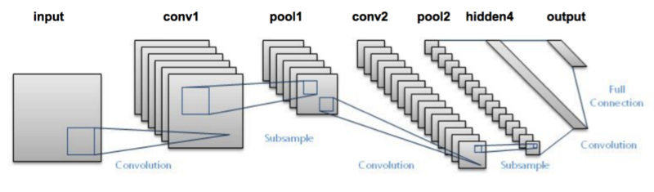

* The two diagrams above show two views of the same LeNet-5 architecture, the first one is a logical view and the second one is a bit more of a “technical” view. You can see how it retains the hierarchical architecture of the primary visual cortex discovered by Hubel and Wiesel and leveraged by Fukushima in his neocognitron. Similar to those systems, the leftmost layer represents simple edges, while successive layers represent increasingly complex features. By processing information in this way, a handwritten “2” should, for example, be correctly recognized as the number two (highlighted by the green output shown on the right).*

A figure shows the hierarchical architecture of the LeNet-5 model which has similarities of the architecture in the primary visual cortex given by Hubel and Wiesel. The architecture starts with an input image. The input image here is "numeral 2" which is sent to the next layer. This layer breaks down large simple features. The successive layers break down smaller but more complex features. The layers are represented using cuboid boxes, whose thickness decreases and length increases, as the layers increase. At the end, these become strips. The final layer gives probability outputs which recognizes the correct number and gives the output.

*9. Fukushima, K., & Wake, N. (1991). Handwritten alphanumeric character recognition by the neocognitron. IEEE Transactions on Neural Networks, 2, 355– 65.*

*10. LeCun, Y., et al. (1998). Gradient-based learning applied to document recognition. Proceedings of the IEEE, 2, 355– 65. 11.*

LeNet-5 was the first convolutional neural network, a deep learning variant that dominates modern machine vision and that we will study later. Their classic dataset, the handwritten MNIST digits, is used extensively in Part II, “Essential Theory Illustrated.” Backpropagation, often abbreviated to backprop, facilitates efficient learning throughout the layers of artificial neurons within a deep learning model. Don’t worry! we’ll be studying Backpropogation in detail later in this book.

Together with the researchers’ data, processing power and the backprop algorithm rendered LeNet-5 sufficiently reliable to become an early commercial application of deep learning: It was used by the United States Postal Service to automate the reading of ZIP codes (US postal service term for postal code) written on mail envelopes. Later in this book, we will use the same LeNet-5 architecture to recognize handwritten digits.

In LeNet-5, Yann LeCun and his colleagues had an algorithm that could correctly predict the handwritten digits that had been drawn without needing to include any expertise about handwritten digits in their code. As such, LeNet-5 provides an opportunity to introduce a fundamental difference between deep learning and the traditional machine learning ideology.

As conveyed by Figure 1.12, the traditional machine learning approach is characterized by practitioners investing the bulk of their efforts into engineering features. This feature engineering is the application of clever, and often elaborate, algorithms to raw data in order to preprocess the data into input variables that can be readily modeled by traditional statistical techniques. These techniques— such as regression, random forest, and support vector machine— are seldom effective on unprocessed data, and so the engineering of input data has historically been a prime focus of machine learning professionals.

 *Feature Engineering, quite simply, is the “science/art” of representing data in the best way possible for ML algorithms to be effective. Why “science/art”? Because good feature engineering involves an elegant blend of domain knowledge, intuition, and basic mathematical abilities. Actually, a lot of the most effective data representation “hacks” barely involve any mathematical computation at all! What does “best” mean? In essence, the data is presented to the algorithm should denote the pertinent structures/properties of the underlying information in the most effective way possible. When you do feature engineering, you are essentially converting your data attributes into data features. Attributes are basically all the dimensions (columns) present in your data. But do all of them, in the raw format, represent the underlying trends you want to learn in the best way possible? Maybe not. So, what you do in feature engineering, is pre-process your data so that your model/learning algorithm has to spend minimum effort on wading through noise. What I mean by ‘noise’ here, is any information that is not relevant to learning/predicting your ultimate goal. In fact, using good features can even let you use considerably simpler models since you are doing a part of the thinking yourself.*

Feature engineering— the transformation of raw data into thoughtfully transformed input variables— *often predominates the application of traditional machine learning algorithms*. In contrast, the application of deep learning often involves *little to no feature engineering*. The majority of time is spent instead on the design and tuning of the deep learning model architecture. In contrast, a minority of the traditional ML practitioner’s time is spent optimizing ML models or selecting the most effective one from those available.

The deep learning approach to modeling data turns these traditional ML priorities upside down. The deep learning practitioner typically spends little to none of her time engineering features, instead spending it modeling data with various artificial neural network architectures that process the raw inputs directly into useful features *automatically*. This distinction between deep learning and traditional machine learning is a core theme of this book.

But for a long time, traditional machine learning, despite its feature engineering issues, was considered to hold more promise, and funding shifted away from deep learning research. This was understandable as, at the time, there were stumbling blocks associated with optimizing deep learning models. This included poor weight initializations (we’ll cover this in later chapters), covariate shift (also in later chapters), and the predominance of the relatively inefficient sigmoid activation function (later chapters). Public funding for artificial neural network research ebbed globally, with the *notable exception* of continued support from the Canadian federal government, enabling the Universities of Montreal, Toronto, and Alberta to subsequently become powerhouses in the field.

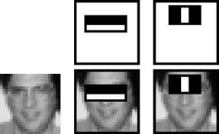 *Here you see a celebrated example of successful feature engineering from Paul Viola and Michael Jones in the early 2000s. Viola and Jones employed rectangular filters such as the vertical or horizontal black-and-white bars shown in the figure. These features generated by passing rectangular filters over an image were fed into machine learning algorithms to reliably detect the presence of a face. Their efficient algorithm found its way into Fujifilm cameras, facilitating real-time auto-focus. In the figure, the combinations of rectangular filters and an original image used for the purpose of reliable face recognition are shown. The first filter is a horizontal white bar inside a horizontal black rectangular box. The second filter is a white vertical bar inside a black rectangular box. The original image is a thumbnail of a person's face. Both filters cover the eye region of the person's face. This work is notable because the algorithm was efficient enough to be the first real-time face detector outside the realm of biology.*

Devising clever face-detecting filters to process raw pixels into features for input into a machine learning model was accomplished *via years of research and collaboration* on the characteristics of faces. And, of course, it is limited to detecting faces *in general*, as opposed to being able to recognize a particular face as, say, your own face or your favorite person’s face. To develop features for detecting your face in particular, or for detecting some non-face class of objects like houses, cars, or cricket balls, would require the development of expertise in that category, something that could again take years of academic-community collaboration to execute both efficiently and accurately. The machine vision community was looking for a way out of this tricky problem.

ImageNet and the ILSVRC

The success LeNet-5 had over the neocognitron was catalyzed by the availability of *a larger, high-quality set of training data*. There was a clear recognition among the scientific community that data driven discoveries were cropping up many research areas. The next breakthrough in neural networks was also catalyzed by a high-quality public dataset, this time much larger. ImageNet, a labeled index of photographs devised by computer science professor Fei-Fei Li armed machine vision researchers with an immense catalog of training data. For reference, the handwritten digit data used to train LeNet-5 contained tens of thousands of images. ImageNet, in contrast, contains tens of millions. The 14 million images in the ImageNet dataset are spread across 22,000 categories. These categories are as diverse as container ships, leopards, starfish, and elderberries.

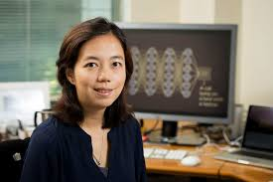

Fei-Fei Li

The massive ImageNet dataset was the brainchild of a computer science professor Fei-Fei Li and her colleagues at Princeton in 2009. Now a faculty member at Stanford University, Li is also the chief scientist of A.I./ ML for Google’s cloud platform. In 2010, Li began running an open challenge called ILSVRC (the ImageNet Large Scale Visual Recognition Challenge) on a subset of the ImageNet data. This challenge has, over time, become the premier ground for assessing the world’s state-of-the-art machine vision algorithms. The ILSVRC subset consists of 1.4 million images across 1,000 categories. In addition to providing a broad range of categories, many of the selected categories are breeds of dogs, thereby evaluating the algorithms’ ability not only to distinguish widely varying images but also to specialize in distinguishing subtly varying ones.

Aside: Just as a thought experiment, try to distinguish photos of Rampur Greyhound from Mudhol Hound. It’s tough, but dog experts, *as well as deep learning machine vision models*, can do it!

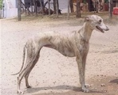 

Rampur Greyhound vs Mudhol Hound

Tangentially, these dog-heavy data are the reason deep learning models trained with ImageNet have a disposition toward “dreaming” about dogs (see, e.g., deepdreamgenerator.com).

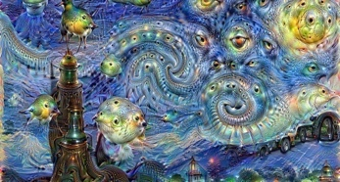

The arrival of the gamechanger a.k.a. AlexNet

The graph above shows that in the first two years of the ILSVRC all algorithms entered into the competition hailed from the feature-engineering-driven traditional machine learning ideology. In the third year, all entrants except one were traditional ML algorithms. If that one deep learning model in 2012 had not been developed or if its creators had not competed in ILSVRC, then the year-over-year image classification accuracy would have been negligible. Instead, Alex Krizhevsky and Ilya Sutskever— working out of the University of Toronto lab led by Geoffrey Hinton— ***crushed*** all existing benchmarks with their submission, today referred to as AlexNet.

AlexNet was the victor by a head-and-shoulders (40 percent!) margin in the 2012 iteration. This was a watershed moment for Deep Learning! Instantly, deep learning architectures emerged from the fringes of machine learning to its fore. Academics and commercial practitioners scrambled to grasp the fundamentals of artificial neural networks as well as to create software libraries— many of them open-source— to experiment with deep learning models on their own data and use cases, be they machine vision or otherwise. Again, as the ILSRVC results graph illustrates, in the years since 2012 all of the top-performing models in the ILSVRC have been based on deep learning. All of the best algorithms since then have been deep learning models.

Things did not stop there. In 2015, machines surpassed human accuracy. In the graph, the horizontal axis represents years and ranges from 2010 to 2017 in increments of 1. The vertical axis represents the top 5 error rate and ranges from 0 to 0.6 in increments of 0.2. A box plot is shown for the year 2010 in which the minimum error value falls at 0.26 and maximum value at 0.45. In the year 2011, the box plot shows a maximum value of 0.5 and a minimum value of 0.24. In the year 2012, the traditional machine learning shows a value of 0.23 but AlexNet showed a lower error rate of 0.18. The plots shown until 2012 is traditional machine learning but after the introduction of the AlexNet, the successive years shows the performance of deep learning. The error rates have a decreasing trend until the year 2017.



*Geoffrey Hinton the eminent British-Canadian artificial neural network pioneer, habitually referred to as “the godfather of deep learning” in the popular press.* *He is an emeritus professor at the University of Toronto and an engineering fellow at Google, responsible for managing the search giant’s Brain Team, a research arm, in Toronto. In 2019, Hinton, Yann LeCun, and Yoshua Bengio were jointly recognized with the Turing Award— the highest honor in computer science— for their work on deep learning.*

*You can see in this figure that AlexNet’s hierarchical architecture is reminiscent of LeNet-5, with the first (left-hand) layer representing simple visual features like edges, and deeper layers representing increasingly complex features and abstract concepts. Shown at the bottom are examples of images to which the neurons in that layer maximally respond, recalling the layers of the biological visual system and demonstrating the hierarchical increase in visual feature complexity. In the example shown here, an image of a cat input into LeNet-5 is correctly identified as such (as implied by the green “CAT” output). “CONV” indicates the use of something called a convolutional layer, and “FC” is a fully connected layer (don’t worry we will formally explain these layer types in later chapters).*

Though the architecture of AlexNet is reminiscent of LeNet-5, there are three principal factors that enabled AlexNet to be the state-of-the-art machine vision algorithm in 2012:

1. Training data: Not only did Krizhevsky and his colleagues have access to the massive ImageNet index, they also artificially expanded the data available to them by applying transformations to the training images (you, too, will do this later).
2. Processing power: Not only had computing power per unit of cost increased dramatically from 1998 to 2012, but Krizhevsky, Hinton, and Sutskever also programmed two GPUs24 to train their large datasets with previously unseen efficiency.
3. Architectural Advances: AlexNet is deeper (has more layers) than LeNet-5, and it takes advantage of both a new type of artificial neuron and a nifty trick that helps generalize deep learning models beyond the data they’re trained on.

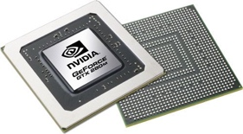  *GPU stands for "Graphics Processing Unit." A GPU is a*[*processor*](https://techterms.com/definition/processor)*designed to handle*[*graphics*](https://techterms.com/definition/graphics)*operations. This includes both 2D and 3D calculations, though GPUs primarily excel at rendering 3D graphics. Early*[*PCs*](https://techterms.com/definition/pc)*did not include GPUs, which meant the*[*CPU*](https://techterms.com/definition/cpu)*had to handle all standard calculations and graphics operations. As*[*software*](https://techterms.com/definition/software)*demands increased and graphics became more important (especially in video games), a need arose for a separate processor to render graphics. On August 31, 1999, NVIDIA introduced the first commercially available GPU for a*[*desktop computer*](https://techterms.com/definition/desktop_computer)*, called the GeForce 256.*

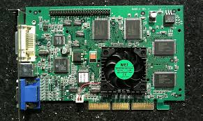

*It could process 10 million polygons per second, allowing it to offload a significant amount of graphics processing from the CPU. The success of the first graphics processing unit caused both*[*hardware*](https://techterms.com/definition/hardware)*and software developers alike to quickly adopt GPU support.*[*Motherboards*](https://techterms.com/definition/motherboard)*were manufactured with faster*[*PCI*](https://techterms.com/definition/pci)*slots and*[*AGP*](https://techterms.com/definition/agp)*slots, designed exclusively for*[*graphics cards*](https://techterms.com/definition/videocard)*, became a common option as well. Software*[*APIs*](https://techterms.com/definition/api)*like*[*OpenGL*](https://techterms.com/definition/opengl)*and*[*Direct3D*](https://techterms.com/definition/direct3d)*were created to help developers make use of GPUs in their programs. Today, dedicated graphics processing is standard – not just in desktop PCs – but also in*[*laptops*](https://techterms.com/definition/laptop)*,*[*smartphones*](https://techterms.com/definition/smartphone)*, and video game consoles. These are designed primarily for rendering video games but are well suited to performing the matrix multiplication that abounds in* ***deep learning*** *across hundreds of parallel computing threads.*

What really makes the industry practitioners view Deep Learning as “Disruptive”?

The ILSVRC case study underlines why deep learning models like AlexNet are considered widely applicable and disruptive across industries and computational applications. *These models dramatically reduce the subject-matter expertise required for building highly accurate predictive models*. This trend away from expertise-driven feature engineering and toward surprisingly powerful automatic-feature-generating deep learning models has been prevalently borne out across not only vision applications, but also, for example, the playing of complex games (the topic of Chapter 4) and natural language processing (Chapter 2).

Today, one no longer needs to be a specialist in the visual attributes of faces to create a face-recognition algorithm. One no longer requires a thorough understanding of a game’s strategies to write a program that can master it. One no longer needs to be an authority on the structure and semantics of each of several languages to develop a language-translation tool. For a rapidly growing list of use cases, one’s ability to apply deep learning techniques outweighs the value of domain-specific proficiency. While such proficiency formerly may have necessitated a doctoral degree or perhaps years of postdoctoral research within a given domain, a functional level of deep learning capability can be developed with relative ease— as by working through this book!

TensorFlow Playground

For a fun, interactive way to crystallize the hierarchical, feature-learning nature of deep learning, make your way to the TensorFlow Playground at bit.ly/ TFplayground. When you use this custom link, your network should automatically look similar to the one shown in the figure below.

In Part II we will return to define all of the terms on the screen; for the present exercise, they can be safely ignored. It suffices at this time to know that this is a deep learning model. The model architecture consists of six layers of artificial neurons: an input layer on the left (below the “FEATURES” heading), four “HIDDEN LAYERS” (which bear the responsibility of learning), and an “OUTPUT” layer (the grid on the far right ranging from –6 to + 6 on both axes).

The network’s goal is to learn how to distinguish orange dots (negative cases) from blue dots (positive cases) based solely on their location on the grid. As such, in the input layer, we are only feeding in two pieces of information about each dot: its horizontal position (X1) and its vertical position (X2). The dots that will be used as training data are shown by default on the grid. By clicking the Show test data toggle, you can also see the location of dots that will be used to assess the performance of the network as it learns. Critically, these test data are not available to the network while it’s learning, so they help us ensure that the network generalizes well to new, unseen data.

*This deep neural network is ready to learn how to distinguish a spiral of orange dots (negative cases) from blue dots (positive cases) based on their position on the X1 and X2 axes of the grid on the right. "A screenshot shows the Tensorflow interface. The interface is divided into four parts, vertically: data, features, hidden layers, and output. Data: four types of dataset are given, of which the spiral type is selected. The ratio of training to test data is set to 50 percent, the noise is set to 0 and the batch size is set to 10. The section has "Regenerate" command button. The next one is "Features" which includes options to select several input layers. Here, two inputs X1 and X2 are selected. To the right of the 'features' is the hidden layers section, with 4 layers placed one next to another. There are add and delete buttons to increase or reduce the number of neurons in each layer. The 4 layers are interconnected. Here, the first layer has 8 neurons, the second layer has 8 neurons, the third layer has 4 neurons and the fourth layer has 2 neurons. There are add and delete buttons to modify the number of hidden layers too. The final hidden layer is connected to the output.*

The output here shows a spiral-shaped graph constituted of orange and blue dots lying alternatively in the graph. In the output, test loss is 0.501 and training loss is 0.509. Below the output is a scale where "colors shows data, neurons and weight values." For pure orange it starts from -1, for white, it is 0, and for blue it is 1. Below this are two checkboxes titled "Show test data" and "Discretize output," both not selected. Click the prominent Play arrow in the top-left corner. Enable the network to train until the “Training loss” and “Test loss” in the top-right corner have both approached zero— say, less than 0.05. How long this takes will depend on the hardware you’re using but hopefully will not be more than a few minutes.

As captured in the figure below, you should now see the network’s artificial neurons representing the input data, with increasing complexity and abstraction the deeper (further to the right) they are positioned— as in the neocognitron, LeNet-5, and AlexNet. Every time the network is run, the neuron-level details of how the network solves the spiral classification problem are unique, but the general approach remains the same (to see this for yourself, you can refresh the page and retrain the network).

The artificial neurons in the leftmost hidden layer are specialized in distinguishing edges (straight lines), each at a particular orientation. Neurons from the first hidden layer pass information to neurons in the second hidden layer, each of which recombines the edges into slightly more complex features like curves. The neurons in each successive layer recombine information from the neurons of the preceding layer, gradually increasing the complexity and abstraction of the features the neurons can represent. By the final (rightmost) layer, the neurons are adept at representing the intricacies of the spiral shape, enabling the network to accurately predict whether a dot is orange (a negative case) or blue (a positive case) based on its position (its X1 and X2 coordinates) in the grid. Hover over a neuron to project it onto the far-right “OUTPUT” grid and examine its individual specialization in detail.

Figure 1.19 The network after training

*The TensorFlow screen shows the output of the trained network. The spiral dataset is selected. The input layer has values X1 and X2 fed into it. There are 4 hidden layers, that have 8 neurons, 8 neurons, 4 neurons, and 2 neurons respectively. The number of hidden layers and the number of neurons in a layer are editable. The output shows a test loss of 0.010 and a training loss of 0.004. The final output shows the blue and orange spiral surrounded by blue or orange region. The blue spiral lies within the blue region and the orange spiral lies within the orange region. This shows that the trained network correctly detected the blue and orange dots with the X1 and X2 coordinates.*

Realtime doodling and machine vision!

To interactively experience a deep learning network carrying out a machine vision task in real time, navigate to quickdraw.withgoogle.com to play the Quick, Draw! game.

Click Let’s Draw! to begin playing the game. You will be prompted to draw an object, and a deep learning algorithm will guess what you sketch. By the end of Chapter 10, we will have covered all of the theory and practical code examples needed to devise a machine vision algorithm similar to this one! To boot, the drawings you create will be added to the dataset that you’ll leverage in Chapter 12 when you create a deep learning model that can convincingly mimic human-drawn doodles. So, come with us on this fantastic journey!

Summary

In this chapter, we explored the history of deep learning from its evolutionary origins through to the AlexNet watershed moment in 2012 that brought the technique to the forefront of scientific attention. Through all of this, the point to keep in mind is that it is the hierarchical architecture of deep learning models that enables them to encode increasingly complex representations. We explored this concept with an interactive demonstration of hierarchical representations in action by training an artificial neural network in the TensorFlow Playground. We then looked at a system that recognizes doodles “automagically” using deep learning!

In the next chapter, we will expand on the ideas introduced in this chapter by moving from vision applications to language applications!